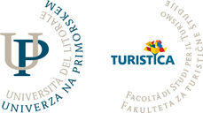
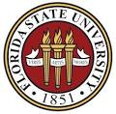

Research Methods Workshop
Thursday 27th October: 11.15 – 13.15
In case you have questions about the workshop: lizineson@gmail.com
In case you wish to register for the workshop: eurochriebudapest@wecotravel.hu
Facilitator: Dr Elizabeth M. Ineson
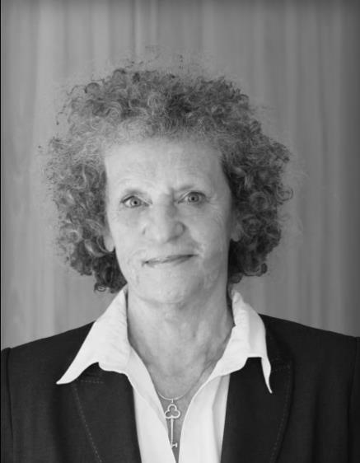
Elizabeth Ineson read Psychology and Mathematics before completing a PhD in Educational Management. She has been awarded fellowship of the Institute of Hospitality and the Institute of Travel and Tourism. In 1999, she won the EuroCHRIE President’s award for outstanding achievement and is currently Director of Research for EuroCHRIE and Operations’ Manager for the charitable trust, La fondation pour la formation hôtelière whose links span 21 Central & Eastern European countries. Liz’s work focuses on experiential and action learning to underpin international research and consultancy through industrial links and staff development. She has conducted over 90 Hospitality research projects and seminars for companies in the UK, USA and Europe and contributed to in excess of 200 publications, conference papers/workshops, short courses, seminars and reports. She was awarded an honorary Professorship by Budapest Business School and she has co-edited seven volumes of International Case Studies for Hospitality, Tourism and Event Management Students and Trainees.

You are invited to participate in this research workshop exemplifies innovative research methods via papers published by a team of international presenters, including:
- Experiments and interviews by Mandy Claudia Tom Dieck
- Online v. on-site data collection by Eva Podovšovnik,
- Auto-ethnography by Joseph Roevens,
- Hierarchical Linear Modelling by Woody Kim
- Design thinking by Xander Lub
- Impact Analysis by Steve Hood
A brief discussion on the use, advantages and disadvantages of these methods follows the presentation after which we would welcome input from any other researchers who have recently employed innovative methodology.
Please see below for further details relating to the presenters.

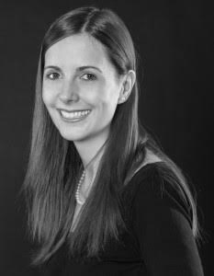 | Dr. M. Claudia tom Dieck is specialised in tourism and hospitality management with a strong focus on digital tourism including social media and augmented/virtual reality. Coming from a hospitality background, with an education from a leading Swiss hotel management school, she worked in hotels in Malaysia and Germany. She is a project manager at the Manchester Metropolitan University Creative Augmented and Virtual Reality Hub ( http://www2.mmu.ac.uk/creativear/) and the Programme Chair of the Annual International AR and VR Conference
 | Eva Podovšovnik is Assistant Professor at the Faculty of Tourism Studies, University of Primorska, Portoroz, Slovenia. She teaches quantitative research methodology, e-tourism and social networks in tourism and is Head of the Commission for students affairs at the Faculty of Tourism Studies. Eva’s research activities focus on methodology and quantitative data analysis (segmentation, public opinion research and data mining).
 | Joseph Roevens (BA Cornell, MA Johns Hopkins, PhD Tilburg) teaches, facilitates and coaches participative forms of HRM, Change Management, Decision-making and Semco-style Leadership. He authored several books and articles on Change, e.g. “Organize with Chaos”, and developed an innovative approach to Leadership, baptized “Leadershiptango”. His approach to research is influenced by phenomenology and the method of embodied participant observation.
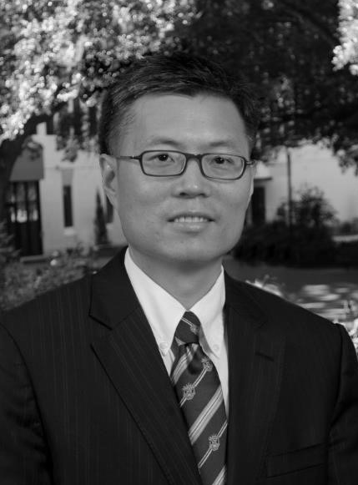 | Woody Kim is the Robert H. Dedman Professor of Hospitality Management and the Director of the International Center for Hospitality Research & Development at Florida State University. He holds a Ph.D. from Purdue University and taught at universities within the U.S. and abroad for the last 20 years. He published more than 100 peer-reviewed articles and made over 100 conference presentations. In 2011, he was recognized in a JHTR article as 5th out of 50 leading hospitality and tourism scholars worldwide in relationship to the productivity at top-tier journals from 2000 to 2009. He has also received the 2004 JHTR Best Article of the Year award from Sage Publication. In 2009, he was honoured with the Institute of Hospitality Education Research Award. Currently, he is an associate editor of the Journal of Quality of Assurance in Hospitality and Tourism. He also sits on the editorial boards of six journals.
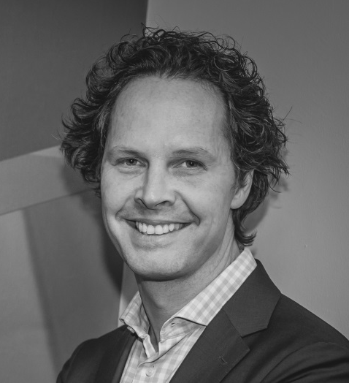 | Xander Lub is Professor of Hospitality Management & Experience Design at NHTV University, Breda, the Netherlands, AHFM/ Senior Lecturer @ VU University. His research covers Hospitality and Experience and Service Design as well as HRM-related issues Dr. Lub has (co-)authored over 70 papers in the last six years and serves as a reviewer for 5 international journals. His work is published in leading scholarly books and international journals in hospitality and management. In 2013, he received the IJCHM Best Paper Award from Emerald. He has consulted to the industry for years, and has about 21 years of teaching and course development experience in Bachelor, Master, MBA, and Executive Education programmes
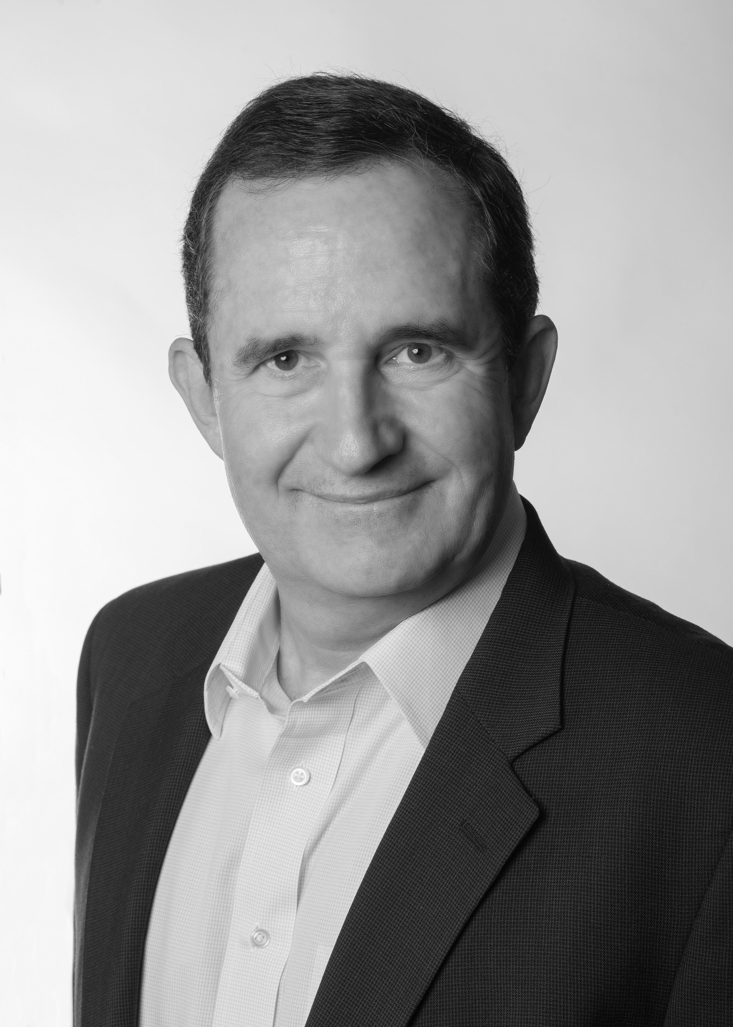 | Steve Hood is Senior Vice President of Research for STR. He is currently responsible for research-related and represents STR at global industry and academic conferences related to hospitality and tourism. He serves on advisory boards and as an honorary professor for leading international hotel schools. In 2012, Steve was recognised by iCHRIE with the Industry Recognition Award and in 2014, he was recognised by EuroCHRIE with the Nestle Pro Gastronomia Award. STR is the leading authority on lodging industry performance trends and performance benchmarking. In 2011, STR launched the SHARE Center, providing hotel and tourism data and additional resources to nearly 600 universities in 60 countries around the world to support their research and classroom activities. It has helped to introduce the “Certification in Hotel Industry Analytics” and the “Hotel Industry Foundations and Introduction to Analytics” certifications for students, professors and industry professionals, jointly offered by AHLEI and STR.

